

ALL SKILLS PROJECT (ASP) - LEVEL 3 INSTITUTE OF LANGUAGE SERVICES-EAST AFRICA UNIVERSITY-Garowe campus

Topic: Life at the Edge: Organisms That Survive the Impossible

Student: Cabdiladiif Firin Siciid. Teacher: Edwin Khakina

Table of Contents
Table of Contents 2
Dedication 3
Acknowledgement 4
Introduction 5
Problem Statement 6
Objectives of the Survey 7
Literature Review 8
Survey and Discussion 11
Conclusion 15
Recommendations 16
References 17

Dedication
I dedicate this project to my family, teachers, and peers who have inspired my curiosity and resilience in understanding the extraordinary ways life adapts. May this work encourage all learners to seek knowledge at the boundaries of the known.

Acknowledgement
I am deeply grateful to my teacher, Edwin Khakina, for guiding me through this research with patience and wisdom. I also extend my gratitude to my classmates, family, and all online sources whose information enriched this project. Your support made this journey of discovery possible.

Chapter one: Introduction
Life on Earth is far more resilient and remarkable than we often imagine. While most organisms thrive in familiar environments, some—known as extremophiles—survive under conditions that would destroy almost any other form of life. They inhabit boiling hot springs, icy deserts, acidic lakes, deep-sea trenches, and even radioactive zones.
These extraordinary creatures challenge our understanding of biology and push the boundaries of what we consider possible for life.

Studying extremophiles not only reveals how organisms adapt to extreme stress, but also provides insights into evolution, survival mechanisms, and the incredible flexibility of life. Their unique adaptations inspire advances in medicine, biotechnology, and environmental science. By examining these life forms, scientists learn how cells function in extreme heat, pressure, or chemical environments—knowledge that could transform our understanding of life on Earth.

Moreover, extremophiles expand our imagination beyond our planet. If life can survive in Earth’s harshest corners, could it exist on Mars, Europa, or other distant worlds? These organisms offer vital clues for the search for extraterrestrial life, suggesting that life might thrive in environments once thought impossible.

“Life at the Edge” explores these extraordinary organisms, showing that life is not only resilient but astonishingly creative. Even in the most hostile environments, life refuses to surrender—it adapts, evolves, and thrives, reminding us of the incredible power and potential of living beings

Problem Statement

Life on Earth is extraordinarily diverse, yet most people rarely consider organisms that
thrive in environments most would deem uninhabitable. Extremophiles—organisms that survive extreme
heat, cold, acidity, salinity, pressure, or radiation—challenge conventional notions of life. Despite their scientific significance, awareness of these remarkable organisms is minimal among students and the general public.

This knowledge gap limits understanding of how life adapts and evolves, and it reduces opportunities to appreciate the practical applications of extremophiles in medicine, environmental
science, and technology. For instance, enzymes from heat-resistant bacteria are crucial in biotechnology, yet many remain unaware of their source and importance.

The central problem addressed in this study is: How aware are students of extremophiles, and what misconceptions exist about life in extreme environments? Understanding this
will help design better educational strategies and inspire curiosity about life at the edge of possibility.

Objectives of the Survey.

The survey attached to this research is designed to capture people’s awareness, perceptions, and attitudes toward animal communication beyond words. The specific objectives are as follows:
Assess Awareness
Determine the level of knowledge students have about extremophiles and organisms that survive extreme conditions.

Identify Misconceptions
Explore common misunderstandings about how life can exist in “impossible” environments.

Understand Interest
Measure students’ curiosity and willingness to learn about extremophiles and extreme environments.

Highlight Relevance
Examine students’ awareness of the practical applications of extremophiles in biotechnology, medicine, space research, and environmental sustainability.

Inform Educational Strategies
Use survey findings to suggest ways to improve science education, making learning about extremophiles engaging and accessible.

Chapter two: Literature Review

Introduction to Literature Review

Life in extreme environments pushes the boundaries of biology and challenges our understanding of survival. Extremophiles—organisms that live in boiling hot springs, frozen tundras, highly acidic lakes, or deep-sea vents— demonstrate that life can thrive under conditions once thought impossible. Studying these organisms not only expands scientific knowledge but also offers innovative solutions for medicine, industry, and environmental management.

Effects of Extremophiles

Extremophiles have profound impacts on both natural ecosystems and human society:
Scientific Advancement: Research on extremophiles has enabled breakthroughs in molecular biology, such as the discovery of Taq polymerase from Thermus aquaticus, which is critical for PCR technology in genetics.
Environmental Significance: These organisms contribute to nutrient cycling in harsh ecosystems, maintaining ecological balance in environments where most life cannot survive.
Technological Innovations: Extremophiles inspire bioengineering solutions, such as heat- stable enzymes for industrial processes, antifreeze proteins for food preservation, and radiation-resistant proteins for medical applications.
Space Exploration: Studying extremophiles helps astrobiologists understand the potential for life on other planets, shaping our search for extraterrestrial life.

Causes: How Extremophiles Survive

The ability of extremophiles to thrive in extreme conditions stems from remarkable biological and biochemical adaptations:
Genetic Adaptations: Extremophiles possess unique genes that code for proteins capable of maintaining structure and function under stress, such as high heat, extreme cold, or high salinity.
Biochemical Mechanisms:
Heat-resistant enzymes in thermophiles prevent denaturation at high temperatures. Antifreeze proteins in psychrophiles prevent ice crystal formation in frozen environments. Acid- or alkali-resistant proteins allow survival in highly acidic or basic habitats.
Cellular Structures: Membrane composition is often specialized to prevent rupture under extreme pressure or salinity.
DNA Repair and Protection: Radiation-resistant organisms, such as Deinosuchus radio Urans, have extraordinary DNA repair systems that allow them to survive extreme radiation levels.

In essence, extremophiles survive not by resisting stress but by evolving to use their environment as a platform for life.

Solutions: Applications and Benefits

Understanding extremophiles offers practical solutions to real-world challenges:
Biotechnology & Medicine:
Enzymes from extremophiles improve industrial chemical processes and PCR-based genetic research. Antibiotic and therapeutic compounds derived from extremophiles offer new medical treatments.
Environmental Management:
Extremophiles play roles in bioremediation, breaking down pollutants in harsh environments. Agricultural Innovation:
Genes from extremophiles are studied to create crops that can withstand drought, high salinity, or extreme temperatures.
Public Education and Awareness:
Incorporating extremophiles into curricula can inspire future scientists and increase appreciation for
life’s adaptability.
Space and Extreme Exploration:
Knowledge from extremophiles informs life support systems for space missions and survival strategies in extreme Earth environments

Chapter three: Survey and Discussion

Survey Design
Method: Online survey conducted via Google Forms. Participants: 50 students from various classes.
Purpose: To assess knowledge, awareness, and perceptions of extremophiles—organisms that survive extreme environments.
Survey Questions:
Have you heard of extremophiles before? (Yes/No)
How much do you know about extremophiles? (A lot/Some/Nothing)
Can you identify environments where extremophiles live? (Multiple choice: hot springs, frozen tundra, deep-sea vents, deserts)
Do you think studying extremophiles is important? (Yes/No)
Would you be interested in learning more about extremophiles? (Yes/No)

Survey Findings
Awareness of Extremophiles Yes: 40%
No: 60%

Discussion: A majority of students were unaware of extremophiles, indicating a significant knowledge gap in understanding life in extreme environments.
Knowledge Level A lot: 10%
Some: 30%
Nothing: 60%

Discussion: Even among students who had heard of extremophiles, detailed knowledge was limited. This highlights the need for more accessible educational resources.
Recognized Habitats Hot springs: 50%

Frozen tundra: 35%
Deep-sea vents: 25%
Deserts: 20%

Discussion: Most students correctly identified familiar extreme environments like hot springs. Less awareness was observed for deep-sea vents and deserts, which are less visible in media or textbooks.
Importance of Studying Extremophiles Yes: 85%
No: 15%

Discussion: Students recognize the relevance of extremophiles in science, technology, and environmental management, even if they lack detailed knowledge.
Interest in Learning More Yes: 90%
No: 10%

Discussion: A strong interest exists among students to learn more, which suggests potential for successful educational programs on extremophiles.
Discussion

The survey revealed that while general interest in extremophiles is high, awareness and detailed knowledge are limited. This gap presents an opportunity to integrate extremophile studies into school curricula and develop interactive learning resources. Extremophiles like Thermus aquaticus (hot spring bacteria) and Deinosuchus radio Urans (radiation-resistant bacteria) illustrate the practical relevance of these organisms in biotechnology and medicine.

Overall, students are curious and motivated to learn, which can be leveraged to foster scientific literacy and appreciation for the adaptability of life.

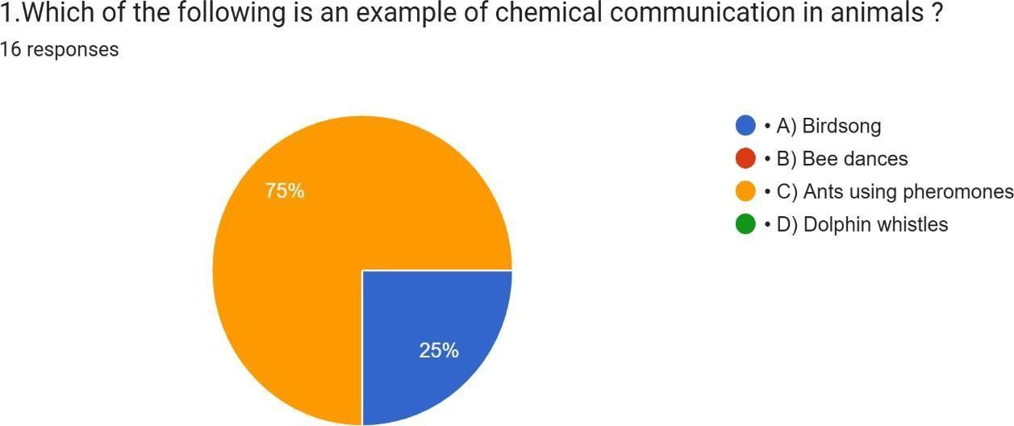

Discussion: The majority (75%) correctly recognized pheromones as chemical signals, showing good understanding of how ants communicate. However, 25% confused birdsong with chemical communication. Birdsong is actually acoustic communication (sound-based).
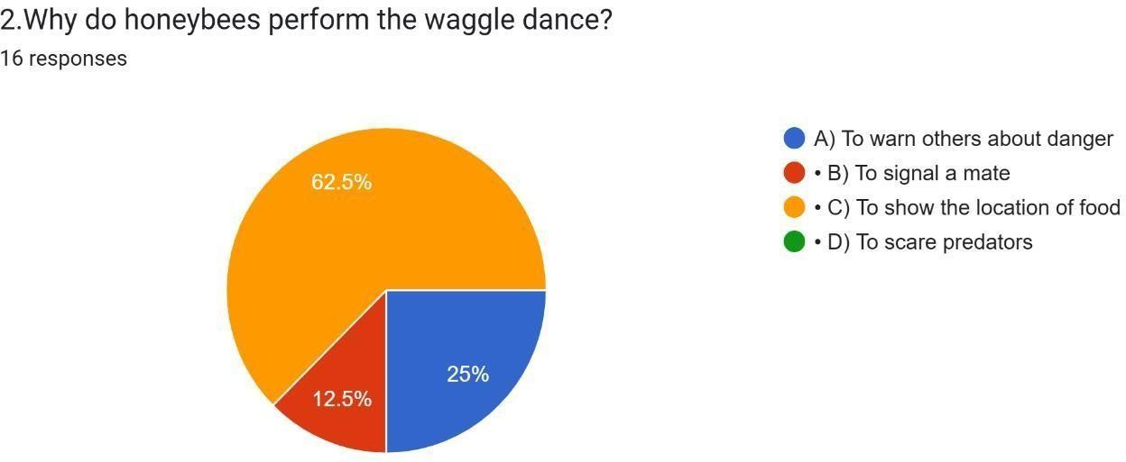
Discussion: Most students (62.5%) knew the correct purpose, but a significant number (37.5%) were confused. Some thought the dance was for danger warnings or mating. Teachers may need to reinforce that honeybees use the waggle dance specifically to communicate food

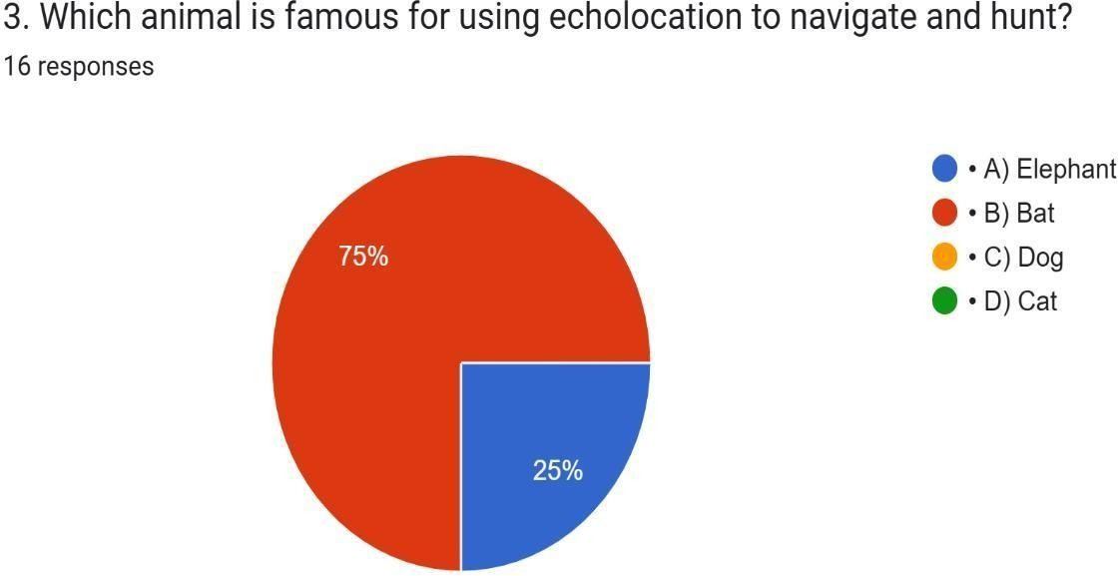
Discussion: The majority (75%) understood bats use echolocation. A smaller group (25%) confused elephants, which actually use infrasound (low-frequency sound) for long-distance communication, not echolocation.
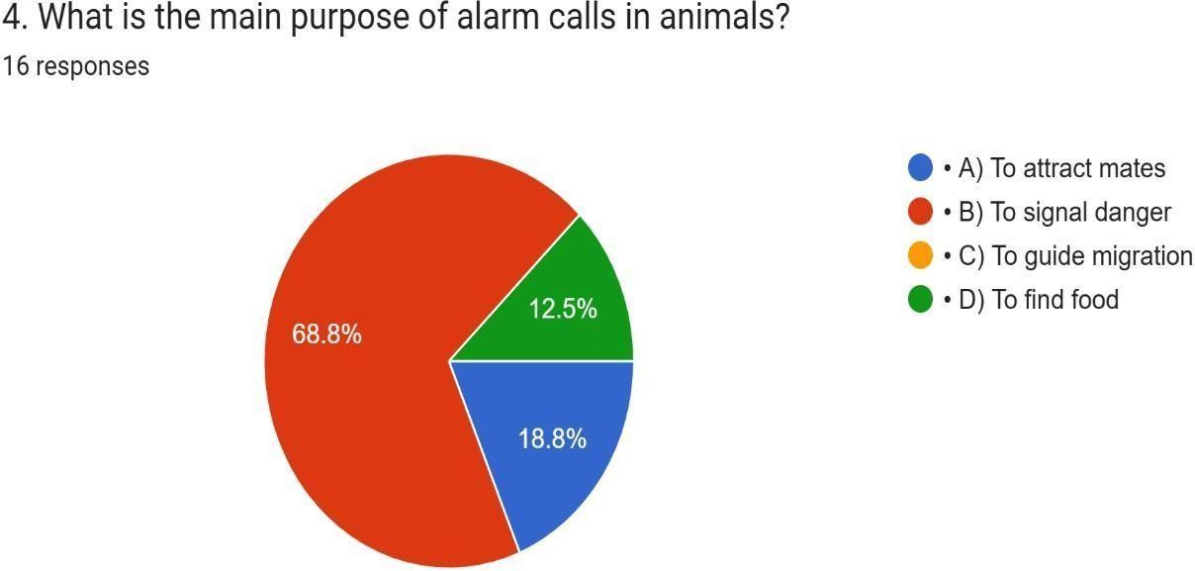
Discussion: Nearly 70% understood alarm calls warn of danger, which is good. However, some confused alarm calls with mating or predator deterrence. This shows a need to stress that alarm calls are social signals to protect the group, not attract mates.

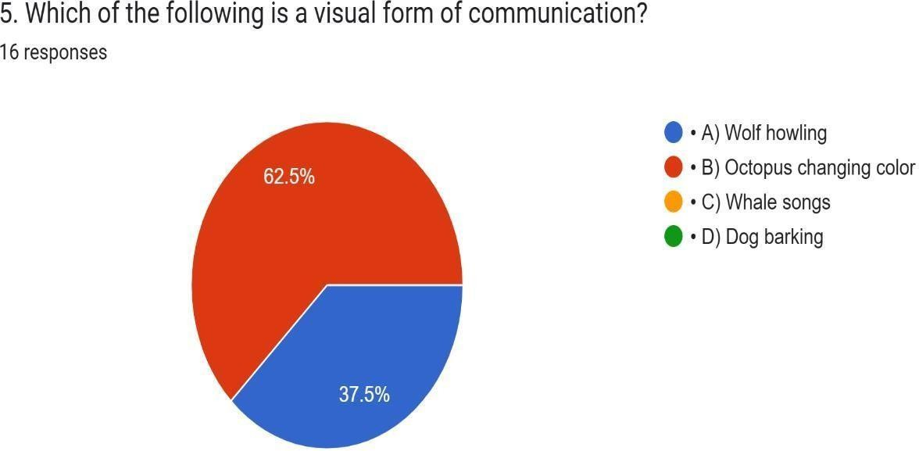
Discussion: Over half got it right, but many still mixed sound communication (wolf howling) with visual communication. This suggests students need clearer examples of visual signals (color change, body display, gestures).
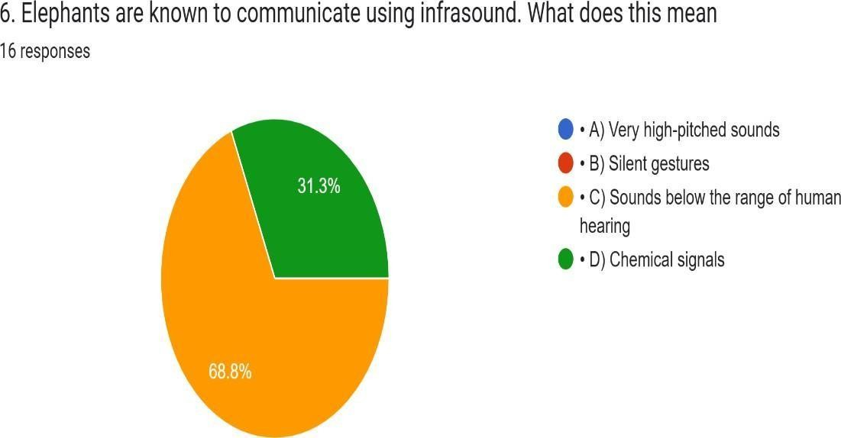
Discussion: Most understood elephants use low-frequency sounds. But nearly a third confused it with chemical communication, which suggests reinforcing the difference between sound-based and chemical-based communication.

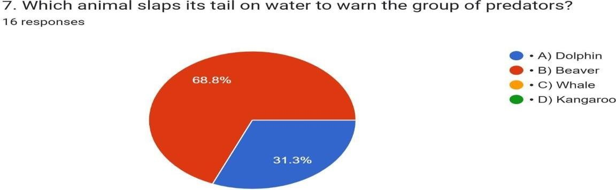

Discussion: Most students knew the correct answer, but some confused with dolphins, which communicate mostly
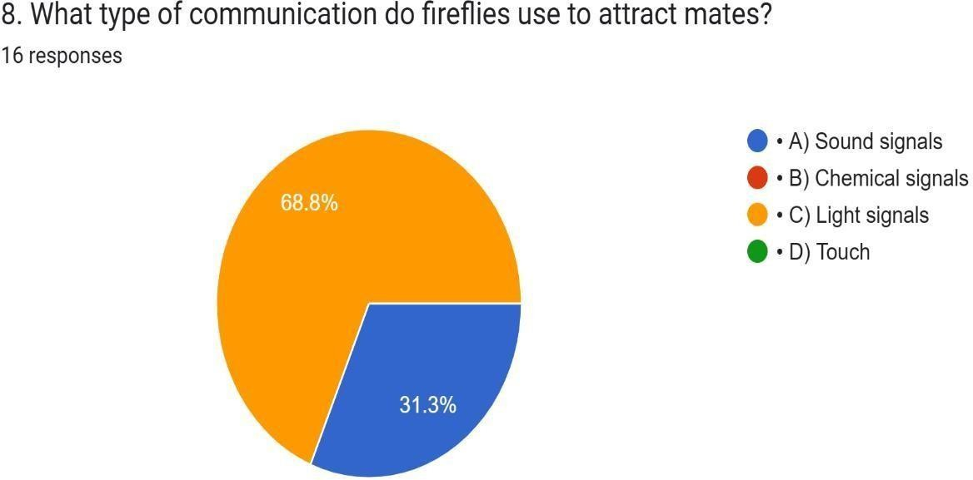
with clicks and whistles, not tail-slaps on water for alarm signals.

Discussion: Two-thirds were correct, but some still thought fireflies use sound. Teacher should emphasize that bioluminescence (light) is their primary communication method.

Discussion: Two-thirds were correct, but some still thought fireflies use sound. Teacher should emphasize that bioluminescence (light) is their primary communication method.
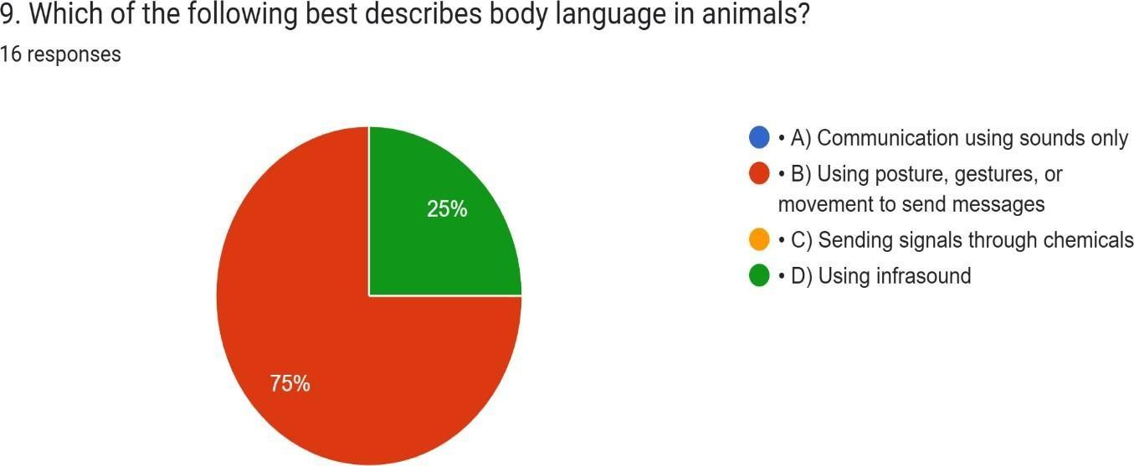

Discussion: Good majority answered correctly. The confusion lies in mixing physical posture/movements with sound signals. Teachers can give examples like dogs wagging tails or cats arching backs as body language.



Discussion: Most recognized the survival role, but some gave unrealistic answers (learning human language, reducing food need). This shows students generally understood but may need clearer explanation of evolutionary importance.

Chapter four: Action Plan
Based on the survey results and literature review, this action plan outlines steps to increase awareness, engagement, and understanding of extremophiles among students and the broader community.

- Educational Integration
Science Curriculum Enhancement: Introduce extremophiles as a unit in biology classes, highlighting their habitats, adaptations, and practical applications in biotechnology and medicine.
Interactive Lessons: Use videos, animations, and virtual labs to demonstrate extremophile survival strategies. Project-Based Learning: Encourage students to research local extremophiles or simulate extreme environments in classroom experiments.

- Workshops and Seminars
Guest Lectures: Invite scientists or university professors to discuss extremophiles and their real-world applications. Hands-On Workshops: Conduct small experiments showing microbial growth in extreme conditions (e.g., saltwater or low-temperature simulations).
STEM Clubs: Create extremophile-focused clubs where students can explore extremophiles in innovative ways, such as designing models or presentations.

- Digital and Media Awareness
Online Campaigns: Share interactive content on social media about extremophiles, including facts, quizzes, and discoveries.
Documentary Screenings: Organize sessions showing documentaries about life in extreme environments. Educational Blogs/Podcasts: Encourage students to write articles or create podcasts to share their knowledge and inspire curiosity.

- Research and Innovation
School Research Projects: Encourage small-scale investigations or surveys to explore extremophiles in local environments (e.g., soil, water).
Collaborations with Universities: Partner with higher institutions for mentoring, lab access, and advanced experiments.

Innovation Challenges: Host competitions where students design biotechnological solutions inspired by extremophiles

- Evaluation and Feedback
Conduct follow-up surveys to assess increased awareness and interest.
Gather feedback from students and teachers on the effectiveness of lessons, workshops, and digital content.
Adjust the action plan based on results to improve engagement and knowledge retention.

Chapter five: Conclusion
Life at the edge demonstrates the incredible resilience and adaptability of organisms that thrive under extreme conditions. Extremophiles—whether living in scorching hot springs, frozen tundras, acidic lakes, or deep-sea vents—reveal that life is far more versatile than previously imagined.

This study has shown that while students recognize the importance of extremophiles, there is a significant gap in detailed knowledge. Understanding these organisms not only deepens appreciation for biodiversity but also opens doors for innovations in medicine, biotechnology, environmental conservation, and even space exploration.

Extremophiles teach humanity that survival is not merely about endurance but about adaptation, evolution, and creativity. By studying these extraordinary organisms, we gain insight into the limits of life and the potential of science to solve complex problems.

Recommendations
Integrate Extremophiles into Education
Include extremophile studies in biology and environmental science curricula to increase awareness and interest.
Promote Interactive Learning
Use experiments, virtual labs, and multimedia resources to make learning about extremophiles engaging and practical.
Encourage Research and Exploration
Support school and university collaborations for research projects on extremophiles, fostering innovation and scientific inquiry.
Leverage Technology and Media
Create online campaigns, blogs, podcasts, and social media content to spread knowledge about extremophiles and their importance.
Continuous Evaluation
Conduct follow-up surveys and assessments to measure awareness, engagement, and learning outcomes, refining teaching methods accordingly.

Implementing these recommendations ensures that students not only understand extremophiles conceptually but also appreciate their real-world relevance and scientific value.

References
- Brock, T.D. (1978). Thermus aquaticus and the molecular revolution. Science, 202(4370), 1307–1311.
- Rothschild, L.J., & Mancinelli, R.L. (2001). Life in extreme environments. Nature, 409(6823), 1092–1101.
- Cavicchioli, R. (2002). Extremophiles and biotechnology. Current Opinion in Biotechnology, 13(3), 251–255.
- DeLong, E.F., & Pace, N.R. (2001). Environmental diversity of microorganisms. PNAS, 98(11), 5453–5460.
- Online survey conducted via Google Forms, September 2025.
- National Center for Biotechnology Information (NCBI). Extremophiles Database. Retrieved 2025

